Imperialism and Foreign Aid in Sub Saharan Africa: Course Description

“I've never really wanted to go to Japan. Simply because I don’t like eating fish. And I know that's very popular out there in Africa.” – Brittney Spears
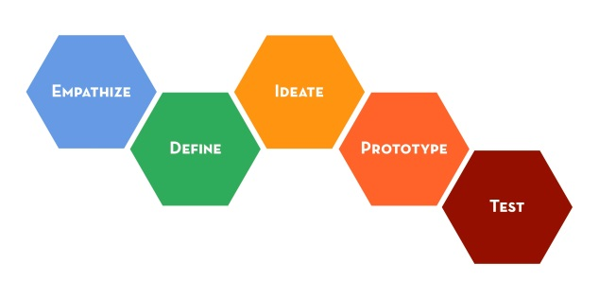
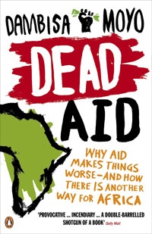
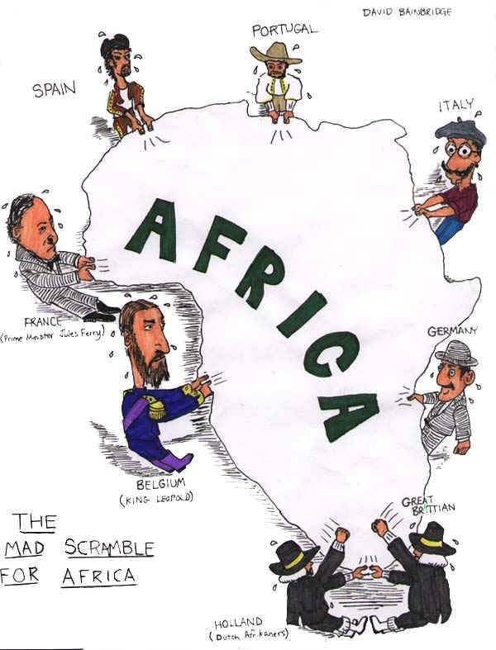

“No other continent has endured such an unspeakably bizarre combination of foreign thievery and foreign goodwill.” – Barbara Kingsolver

Key Terms
Term/Concept | Definition
Sub Saharan Africa | The region of Africa south of the Saharan desert
Imperialism | The policy of extending a nation's authority by territorial acquisition or by the establishment of economic and political hegemony over other nations
Humanitarian Assistance | Aid and action designed to save lives, alleviate suffering and maintain and protect human dignity during and in the aftermath of emergencies
Foreign Aid | A voluntary transfer of resources from one country to another. It may be given by individuals, private organizations or governments
Neo-colonialism | The geopolitical practice of using capitalism, business globalization, and cultural imperialism to influence a country, in lieu of either direct military control or indirect political control
Post-colonialism | An academic discipline featuring methods of intellectual discourse that analyze, explain, and respond to the cultural legacies of colonialism and of imperialism, to the human consequences of controlling a country and establishing settlers for the economic exploitation of the native people and their land

Essential Questions
- What is the legacy of imperialism in Sub Saharan Africa?
- To what extent is Western aid effective in helping address poverty in Sub Saharan Africa?
- What are ineffective and effective approaches to humanitarian and development aid?
- What is the “story” of Africa? What stories are missing from the dominant discourse? What are the dangers of a single story?
Course Overview
“The continent is too large to describe. It is a veritable ocean, a separate planet, a varied, immensely rich cosmos. Only with the greatest simplification, for the sake of convenience, can we say 'Africa'. In reality, except as a geographical appellation, Africa does not exist.” ― Ryszard Kapuściński, The Cobra's Heart
This course aims to deconstruct stereotypical notions of “Africa” as we zoom in on the legacy of imperialism and humanitarian aid in Sub Saharan Africa. We will study European Imperialism of Africa during the late 1800’s through early 1900’s with a particular focus on the Congo, frequently referred to as “the heart of Africa”. The Congo has been the battleground for various European and African nations’ quest for economic prosperity and political power promised by its wealth of natural resources, beginning with Belgian’s merciless and brutal King Leopold II, whose “acquisition” of the Congo and horrific treatment of Congolese people lasted from 1885 through 1908. We will read The Heart of Darkness by Joseph Conrad, which is a classic (yet controversial) novella about Leopold’s exploitation of the Congo Free State. Students will learn how to write a literary analysis essay as they develop their own response to The Heart of Darkness.
We will then move on to examine anti-imperialism rhetoric and independence efforts by Congolese and Kenyan leaders in the 1960’s to better understand the perspectives of Sub Saharan Africans and their efforts to reclaim their peoples and lands in the face of European conquest and control.
Next, we’ll study neocolonialism and the legacy of imperialism in modern times to better understand the consequences (both positive and negative) of European Imperialism. One result of imperialism is humanitarian aid, a double-edged sword of sorts in that is has been both a blessing and a curse to Sub Saharan Africa. On this note, we will turn our attention to our second essential question: “To what extent is Western aid effective in helping address poverty in Sub Saharan Africa?” as we read Dambisa Moyo’s controversial book, Dead Aid, in which she argues that we should end charity to Africa because it encourages corruption and conflict while discouraging free enterprise. In this unit, we will also seek to challenge the single story so often told about Africa, which Binyavanga Wainaina captures in his ironic essay entitled, “How to Write about Africa” as he prescribes:

In your text, treat Africa as if it were one country. It is hot and dusty with rolling grasslands and huge herds of animals and tall, thin people who are starving. Or it is hot and steamy with very short people who eat primates. Don’t get bogged down with precise descriptions. Africa is big: fifty-four countries, 900 million people who are too busy starving and dying and warring and emigrating to read your book. The continent is full of deserts, jungles, highlands, savannahs and many other things, but your reader doesn’t care about all that, so keep your descriptions romantic and evocative and unparticular.

One way we will seek to combat these stereotypes Wainaina describes will be by reading various short stories by modern African authors who are writing about Africa in a multitude of ways.

Lastly, we will examine an approach to aid, and more generally, an empathetic and creative approach to problem-solving taught by Stanford’s Design-School called “design thinking”. While design thinking has become part of the popular language in contemporary design and engineering practice, as well as business and management, its broader use in describing a particular style of creative thinking-in-action is having an increasing influence across disciplines. In the field of aid, it has been used as tool for participant-driven change, where those whom an organization or individual wishes to serve play an integral role in developing solutions for problems they have identified in their community.

Assessments
This is a seminar course, which means that you, the students, do most of the talking. In order for this course to be successful, you need to come to class having completed the readings and ready to engage in critical discourse. Late work will not be accepted. Period. You will only be graded on the following five assessments:
- Tumblr Participation (ongoing) 10%
- Heart of Darkness Literary Analysis Essay 25%
- Midterm Exam 25%
- Final Project 30%
- Course Reflection and Synthesis 10%
Syllabus and Core Texts
Unit 1: Imperialism 1884-1908
- “How to Write about Africa” by Binyavanga Wainaina

- Philosophies of Imperialism
  - “The White Man’s Burden” by Rudyard Kipling compared with John O’Sullivan’s coinage of the phrase “Manifest Destiny” during the Mexican-American War
  - Social Darwinism
  - Theories of Imperialism

- The Scramble for Africa
  - “15 Minute History” podcast
  - Map of world Imperialism
  - Map before the Scramble
  - A French Viewpoint on Imperialism (1891) by Paul Leroy Beaulieu
  - The Berlin Conference
  - Map after the Scramble
  - “Confession” by Cecil Rhodes: Written long before he accumulated enormous wealth from gold and diamond mines in South Africa and endowed his famous scholarships, Rhodes articulated his vision of Anglo-Saxon world-domination.
  - Role of European Imperialism propaganda, i.e. “The Sacred Mission of Civilisation” by King Leopold II

- Leopold and the Congo
  - Heart of Darkness by Joseph Conrad and relevant primary source documents
  - Overview of key movements including liberalism, existentialism and modernism
  - Letter from King Leopold II of Belgium to Minister Beernaert on the Congo, July 3, 1890
  - “Black Man’s Burden” by Ed Morel
  - "An Image of Africa: Racism in Conrad's 'Heart of Darkness'" by Chinua Achebe
  - “Shooting an Elephant” by George Orwell

- Possible films:
  - Khartoum
  - Apocalypse Now
Unit 2: Postcolonialism and Independence 1960’s
- “Gentleman of the Jungle” by Jomo Kenyatta
- Congo Wars
- Frantz Fanon (anti-imperialist writer and activist)
  - Satre’s preface to Wretched of the Earth
- I speak of freedom (1961) by Kwame Nkrumah
- Various readings by and about Patrice Lumumba: First Prime Minister of the Democratic Republic of Congo and Congolese Independence leader
- Film: Black Skin, White Mask (1966)
- Possible guest speakers:
  - Fred Ochieng’: Co-founder of The Lwala Community Alliance
  - Neil McHugh: Professor of History at Fort Lewis College
Unit 3: Legacy of Imperialism + Neocolonialism (Present Day)
- "Neo-Colonialism, the Last Stage of imperialism" by Kwame Nkrumah 1965
- Crisis in the Congo: A short documentary looking at the situation in Central Africa.
- “Good Governance for Africa” by Julius Nyerere (1998)
- All Cultures are not Equal: by Kenan Malik 2002
- "Colonialism and its Legacies in Kenya" by Professor Peter O Ndege
- What is Structural Adjustment and what are its effects?

Unit 4: Foreign Aid & The Single Story
We will critically examine foreign aid today through various aid efforts from the Lwala Community Alliance and GiveDirectly to the UN Millenium Project and Unicef. Additionally, we will try to challenge the dangers of a single story too often perpetuated by charity propaganda schemes.
- Dead Aid by Dambisa Moyo + Criticism of
- Democracy has by-passed the Poor by Zwelinzima Vavi
- Forced Migration Review: Humanitarian Aid Fulfilling its Promise?
- The Dangers of a Single Story, Ted Talk by Chimamanda Ngozi Adichie
- Selected short stories by acclaimed African authors
- Charity and its deleterious effects on African stereotypes
  - Irony: Rusty Radiator: Let’s Save Africa!
- This American Life podcasts on Foreign Aid
- Why Africa is turning to China

Unit 5: Design Thinking
- Excerpts from Pedagogy of the Oppressed by Paolo Freire
- Embracing the Beginner's Mindset
- NPR: Lessons in Leadership
- The Australian Centre for Social Innovation (TACSI)
- Stanford’s Design School
- Mini-projects/experiential activities to understand the process of design-thinking

Unit 6: Applying Knowledge (Project!)
Under Mental Construction

http://www.globalhumanitarianassistance.org/data-guides/defining-humanitarian-aid
http://en.wikipedia.org/wiki/Aid
http://en.wikipedia.org/wiki/Neocolonialism
http://en.wikipedia.org/wiki/Postcolonialism
http://textandcommunity.gmu.edu/2009/resources/how-write.pdf

